Credit Name

2140

Credit Assignment

E6 math tutor

How has your program changed from planning to coding to now? Please explain?

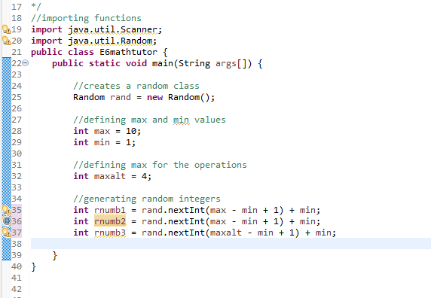

Making the random numbers

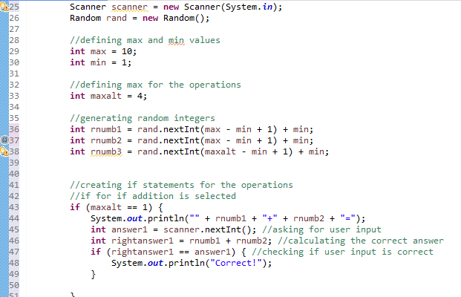

Creating if statements for which operation type is selected

Creating if statement for subtraction

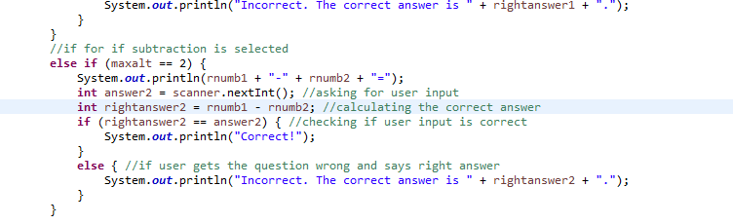

Wrong value for the if statement 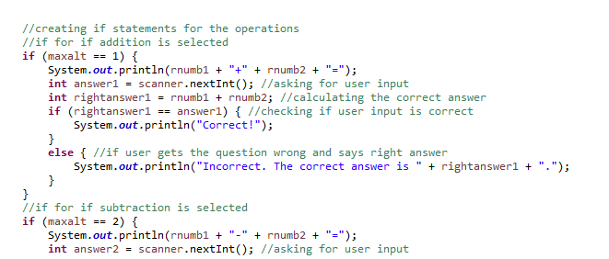

Should be rnumb3 not maxalt, easy fix just needs to be replaced

Final error, now it's good